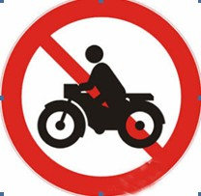
Notice for Forbidding Riding Motorbikes
International students are forbidden to ride motorbikes as our school has announced many times according to the Administrative Regulations of SNNU. But recently, some students are still found to ride motorbikes in campus against regulation, even at a high speed. For security reasons, the regulations are announced again as follows:
1. International students are forbidden to buy or ride motorbikes, especially in the campus.
2. Anyone who has bought motorbike must dispose of it.
3. Anyone who breaks the regulation after the deadline will be severely punished. At that moment, your motorbike will be confiscated by the Public Security Office of SNNU; you will even be punished by School Expulsion, Visa Cancellation accordingly.
Related students should properly deal with your motorbikes as soon as possible and not ride motorbikes any more.

